Problem:
Frequent team stacking
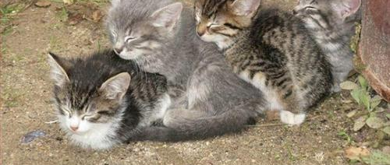

Solution:
Program a vote scramble command
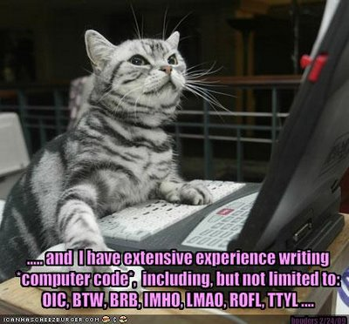
Kittens playing TF2 can then vote whether they would like a scramble or not. This will hopefully prevent nerd-rage as seen in the figure below.


